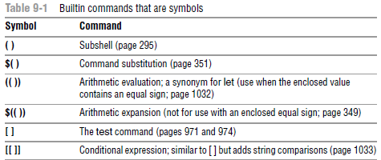

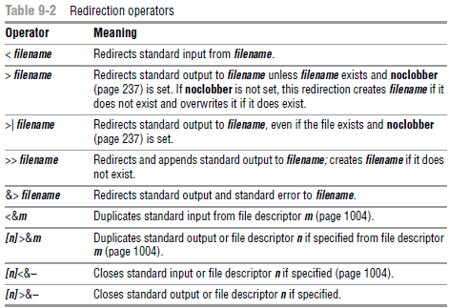

; and NEWLINE Separate Commands

| and & Separate Commands and Do Something Else

|| and && Boolean Control Operators

( ) Groups Commands

\ Continues a Command

**jobs: Lists Jobs**

fg: Brings a Job to the Foreground

**Suspending a Job**

bg: Sends a Job to the Background

**Manipulating the Directory Stack**

dirs: Displays the Stack

pushd: Pushes a Directory on the Stack

popd: Pops a Directory Off the Stack

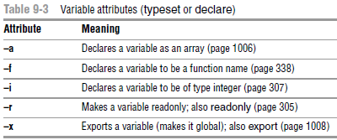

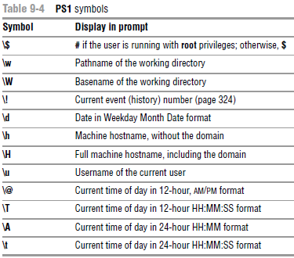

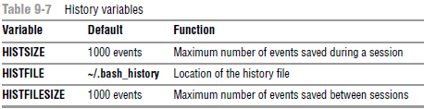

**Re-executing and Editing Commands**

fc: Displays, Edits, and Re-executes Commands

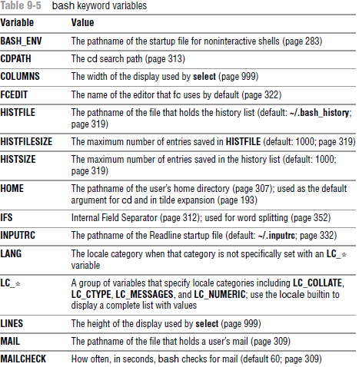

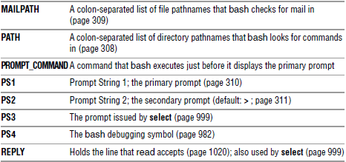

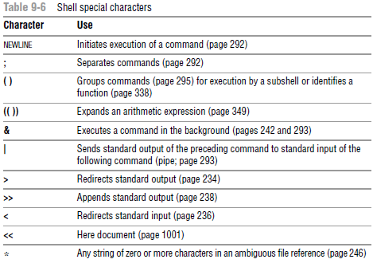

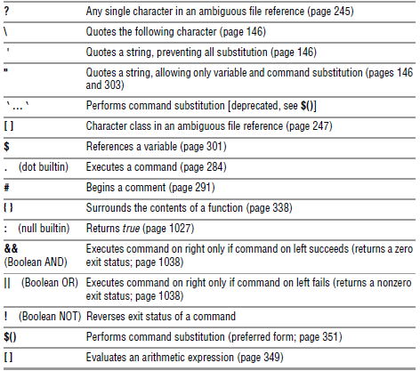

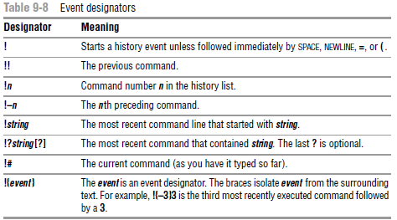

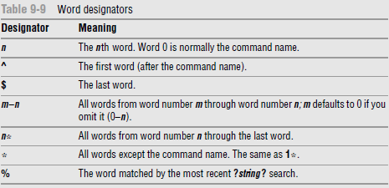

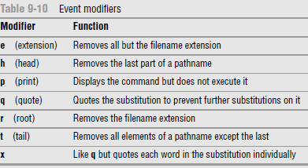

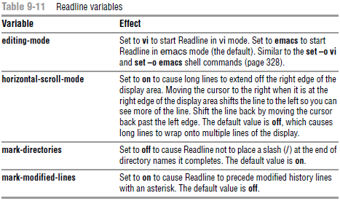

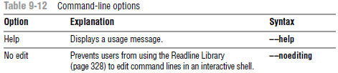

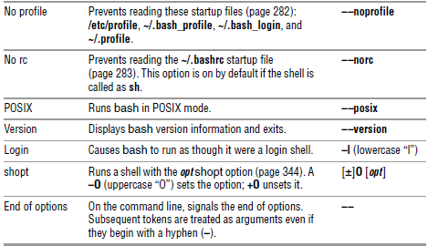

**Shell Features**

set **±**o: Turns Shell Features On and Off

shopt: Turns Shell Features On and Off

